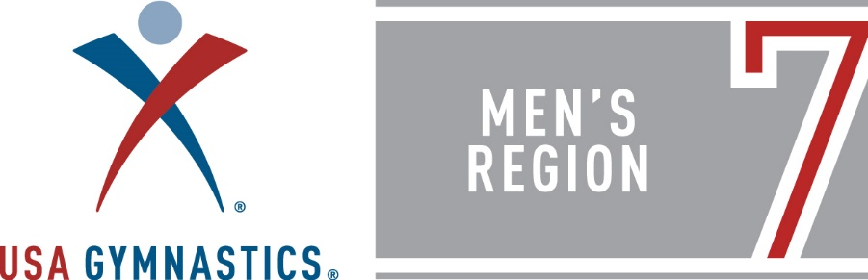

Region 7 Future Stars Regional Championships and Clinic
October 16 & 17, 2021
Hosted by Williamsburg Gymnastics 144-A Tewning Rd Williamsburg VA 23188
Details:
- $100 Entry Fee – Payable to “USA Gymnastics Region 7 Mens”
- Enter in the USAG Meet Registration System
- Payments mailed to: Region 7 Gymnastics | C/O Richard Pulsfort | 529 Maple Ave | Elizabeth NJ | 07202
- Tentative schedule will have all competitors in one session on Sunday, mid-day.
- ANY athlete wishing to compete in Future Stars is welcome.

Age | Birth Year
8-year-old | 2013
9-year-old | 2012
10-year-old | 2011 | Can progress to National Testing
11-year-old | 2010 | Can progress to National Testing
12-year-old | 2009 | Can progress to National Testing

- Qualification scores to Nationals have NOT been released as of the date of this publication.

Future Stars National Testing
Location: TBA
Date: November 17th - 21st

Region 7 Elite Team Training Clinic
October 16 & 17, 2021
Hosted by Williamsburg Gymnastics 144-A Tewning Rd Williamsburg VA 23188
Details: (limit to 30 gymnasts)
- $100 Entry Fee – Payable to “USA Gymnastics Region 7 Mens”
- Enter in the USAG Meet Registration System
- Payments mailed to: Region 7 Gymnastics | C/O Richard Pulsfort | 529 Maple Ave | Elizabeth NJ | 07202
- All interested Level 10 Athletes & Coaches are welcome to attend.
  - Region 7 is looking for 6 AA athletes that can score 78+ under the new Code of Points.
  - Final Start Values should be upwards of 14.0+ on most (if not all) events.
  - Athletes should be aiming for final scores at a 13.0 or higher across all 6 events.

Elite Team Cup – February 23 – 27, 2022 TBD
The Region 7 delegation will comprise 6 members, and 1 alternate (non-traveling). Current Level 10 Jr. National Team members have an automatic spot on the Region Elite Team. The region is looking for scores from athletes that have competed in the following meets:
- Greater New York Invitational – December 4 & 5, 2021
- West Point Open – January 14 – 16, 2022
- Gymnasts can submit routine videos to be considered to Dropbox by January 16th. (https://www.dropbox.com/sh/23dtovqdyjg67iv/AABtBjCBEI28xl9A2pb7I2DIa?dl=0)
- Final determination for team members will be February 1, 2022

