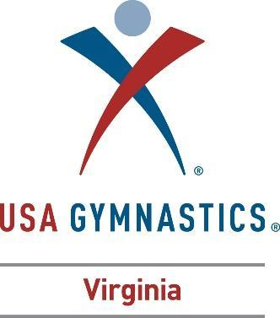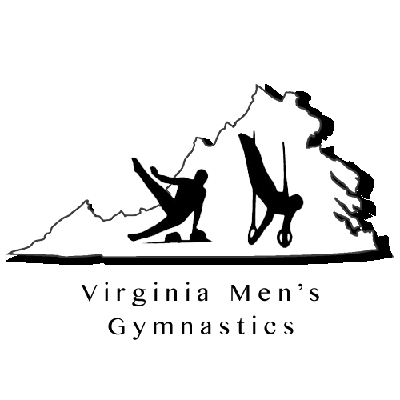

Graduating Senior Recognition

Virginia Men’s Gymnastics would like to honor all Graduating Seniors at the State Championship Meet. Information will be shared with the organizers of the State Championship Meet for inclusion in the Meet Program; Virginia Men’s Gymnastics State Website; social media and Region 7 for recognition at the Regional Championship Meet. Please complete this form and submit to Sonja Hird Clark at sonjaeclark@aol.com. In addition to providing the following information, please email one digital copy of a headshot for inclusion in the meet program, social media and state website.

Name of Gymnast:

Club Name:

Name of Coach:

Coaches Comments:

Gymnast Home Address:

Father’s Name:

Mother’s Name:

Present High School:

Gymnastics Career Highlights (include current level and years involved in sport):

Will you be continuing Gymnastics in College?:

Name of College, anticipated major, future goals?

